Relational perspective in designing and conducting research into the Internet

Keywords: research into the Internet, qualitative research, relational perspective
ABSTRACT
From the relational perspective, competent use of the Internet is defined as one that can improve the quality an individual’s life or the efficiency of an institution and, as a result, enable them to function more smoothly/easily in their area of interest (Fliciak, Growiec, Mazurek, 2013).
Thus, research into the Internet cannot be restricted to the online activities of the research participants and requires a broader, relational perspective. Most of our Internet activity exerts a direct influence on the offline spheres of our lives, producing consequences of economic, social, political, cultural and institutional nature. What is more, a relational approach to researching the Internet opens the essence of the study to spheres of the respondents’ lives that are beyond the web. It also expands the pool of viable methodological techniques to include non-digital tools.
In the present article, we draw from our unique experiences of designing, conducting and analysing research into the Internet with the use of the relational approach. For over 5 years we have worked as a duo, combining the perspectives of an academic and market research. The projects which served as a background for the present article comprise a wide range of Internet research methods. The word “Internet” is used here primarily with reference to the field of research and somewhat less to the manner in which research is carried out. This is to say that the Internet constitutes the research environment and, above all, the research subject, whereas the use of Internet methodology is of secondary importance. The methodology is by no means key. For it is not because of the methodology employed that research is classified as “Internet research”. Nor is it necessary to employ Internet tools in the research into the Internet. What is key here is relationality - the broad perspective in the handling of both theoretical and methodological issues.
That is why we chose to apply a triangulation of methods developed in the course of research that covered bloggers, coaches and participants of e-competence workshops, TV series translators, users of the file-hosting service Chomikuj.pl, cultural institutions that use Facebook and those that have implemented the OpenGLAM initiative. In market research terms: we secured a wide variety of respondents by getting involved in all kinds of initiatives - from “business to business” research used to examine institutions to traditional consumer-oriented projects focused on users of online services and target recipients of educational and cultural programmes. Due to the wide range of respondents, the way in which each study was conducted needed to be altered so as to accommodate the different scopes and levels of competence of given type of participants, while also taking into consideration their sense of security.
In our research projects we faced a number of challenges, such as how to successfully investigate Internet pirates, how to evaluate a blogger’s creative skillset or how to assess the reluctance to gain e-competence that proved common among over 60 year-olds.

Research procedure
Research design - Sample selection - Research tools - Field - Systematizing analysis - In-depth analysis - Confrontation with theory - Report

Our experience has taught us that it is always best to follow the same pattern. To begin with, a detailed research design needs to be developed. In order to do that, we reviewed the available literature, assessed the present state of research into the subject and considered the lifestyles and social phenomena that pertain to it.
In comparison to the standard procedure used in research projects, we place extra emphasis on the post-field stage. It is our view that each step is equally important in shaping the final conclusions. That is why it is crucial to continue developing the tools, even after the fieldwork is done. The process does not end the moment we are ready to implement the survey or as soon as the data collection tools have been created.
We particularly want to emphasize that every stage of research plays an equally crucial role in deciding the degree of digitization and the relationality of research questions. We can pose questions about the level of immersion into the Internet at a given stage or about the relevant contexts of the day-to-day lives of the research participants. Depending on the criteria and recruitment paths used, as well as the techniques selected for the guidelines, both the web and the selected spheres of life can play a variety of roles. For instance, an Internet-related subject may be discussed online. Similarly, a topic that has nothing to do with the Internet may be debated via Skype or through an on-line survey. That is why, a JA-MY-ONI [ME-US-THEM] inventory may be more more useful at the analytical stage (when the phenomenon in question has a significant impact on interpersonal relations) than, say, a “tag cloud” which may seem like the most intuitive option as far as Internet research is concerned.
Choosing the way in which the study is carried out is by no means the only, or the last moment to consider the ways of digitizing the whole process. It would be a mistake to assume that it is decided once and for all when we select the data collection tool and that from then on we can do nothing but merely report on our progress. Each step of the way is an opportunity to consider the interdisciplinarity of a given project. It manifests itself as much in the “behind-the-scenes” of the survey as in its final results. When planning out the tasks, we may find it useful to include, for instance, the workshop component - commonly used in strategic and marketing work. When it comes to developing the guidelines, we may want to consider what bloggers do to build their own brand and with that in mind, dig deeper into the subject of recognisability and uniqueness. Terminology used in disciplines related to sociology may come in handy when building a narrative around the results.
What will follow now is a presentation of how to handle, at each stage of the research process, the question of “Internetizing” and “relationalizing” the study, taking into consideration the research participants and their interdisciplinarity in meta-perspective. Our deliberations will be supported by concrete examples drawn from our work.

Research design - study questions / What is culture doing on Facebook?
The moment of identifying the basic intuition behind the research has far-reaching consequences for the degree of “Internetization” of research and for the offline spheres of life that should be investigated.
When planning the course of research and the modules which it will be comprised of, we should challenge the most common models of thinking about Internet research. Traditionally, the majority of Internet-related projects would be based on one of the two most common premises. With the first one, the Internet is treated as a research measure - a novelty to complement the existing research tools. As a result, Internet tools such as instant messengers, forums, blogs, discussion groups etc., have come to be used as data collection tools. The stage at which the participants’ responses are recorded has also moved into the virtual sphere. In most cases, the observations collected online were made in the course of the study. Thus, the online nature of the research boils down to recording the generated data on the net Another (implicit) assumption in typical Internet research is concerned with one of the basic qualities of the Internet: the possibility of generating indicators and statistics and, based on that, conducting research analyses. Particularly such indicators as popularity and effectiveness are widely measured and characterized. That is due to the fact that research often relies on the Internet’s ability to self-monitor and keep a record of all user activities, clicks, views etc. For this reason, a large number of research projects into the Internet focus on phenomena and content that are natural and independent of the study or, in other words, on the existing quantitative data - desk research.
The two most common approaches briefly described above exemplify, on the one hand, passive quantitative measurement and on the other, purely technical use of digital facilitators on a traditional path of research.
When designing our original research project on participation in culture and how it functions within the sphere of social media, we concluded that none of the approaches described above was well-suited to the dynamics of the phenomenon. To employ statistical measure or to force people to reveal their reasons for signing up for events on Facebook would be inconsistent with our initial intuition. Therefore, we chose a methodology that would at the same time saturate the subject matter and establish a framework of what we deem to be pertinent within our field or research. At the planning stage, we agreed that the most effective way to get the fullest picture would be through a triangulation of research methods (Konecki, 2000, p. 77-99). We decided that we would not limit ourselves to just following the Facebook profiles of “cultural entities” - cultural institutions and initiatives. We thought it made sense to step out of the virtual reality and have real-life conversations about those profiles with the people who manage them. Their perspective on Facebook was that of a specialist who uses it for a number of clearly defined purposes: to promote cultural events and build the image of the cultural institution they represent. From this reasoning emerged the two perspectives that dominated our study: the observational perspective and the specialist perspective. The observational perspective would be that of receiving and passively following without any participation. In the relationship through which participation in cultural events is negotiated, the crucial role is played by cultural entities. For this reason, it was the people behind cultural institutions that recounted their Facebook experiences in a more complex and reflective manner. As for the participants of cultural life - they were perceived through the prism of the communications they received, as reflected in the observation diary.
In our view, the combination of those two perspectives gave us a better insight into the phenomenon of a social networking site stimulating cultural life. In both perspectives we followed cultural institutions to get the best possible picture of the management of urban culture and the role of the Internet in the whole process.

Sample selection / 50+ doesn’t exist
It often happens that the field or social fact that we are investigating, carries in itself a suggestion of categories that describe the participants and thus indicates how to calculate and diversify the sample. That was the case with e-competence workshops. One of the most commonly used, recruitment categories of attendees was “50+”. As stated in a number of sources including the “Polish 50+ Consumer” report (Frontczak-Rudnicka, 2013-14), it is purely a “communication shortcut” which does not correspond to a coherent age group. Therefore, based on an analysis of existing data, our team moved beyond the categories of workshops and courses that were already in use. Through this verification, we were able to split workshops into categories such as “for active citizens” and “for senior citizens” which would otherwise have been investigated as part of the same module. We managed to establish a “soft demographics” and thus replace the categories in use with new ones that were better suited to the reality of workshops and courses.
But of course it is the field that proves to be the biggest test. When researching the “Tajni Kulturani” (Filiciak, Danielewicz, Buchner, Zaniewska; 2012) people who were illegally digitizing and sharing cultural content online, the whole research team was left surprised by how demographically diversified the pool of respondents turned out to be. As we were primarily interested in diversification according to types of cultural activity pursued, we allowed a wide range of age groups to participate. As a result, we worked with people of all ages - from middle-schoolers to pensioners. We were thus able to get a better picture of how widespread the evolution of participation in culture had become. It is of great significance that the people that form the hub of an informal circulation of content on the Internet are not, as intuition or stereotype would suggest, students but young moms and grannies. We used the method of purposive sampling with emphasis placed on the criterion of commitment measured by the amount of time and work involved as well as the range of content from films through books to subtitles.
Our use of the purposive sampling model was motivated by our determination to gain knowledge on a very particular and significant type of behaviour and attitude as exemplified by “committed digitizers” of cultural content on the Internet (Filiciak, Danielewicz, Buchner, Zaniewska; 2012, p. 15). As a result, the seemingly essential and valuable criteria of age and other demographic data that apparently determine our online competence, became the subject of our analyses and conclusions because they had not been clearly defined (not to mention closed) at the stage of sample selection.

Sample selection / How to find the secretly cultured?
Also of key importance at this stage of research is the recruitment process. To secure a pool of respondents that fulfil a number requirements imposed by purposive and diversified sampling is not an easy task and usually proves to be extremely time consuming. However, we are convinced that it is worthwhile to search for potential interviewees even within the most problematic target groups, i.e. groups of people whose online activities are in breach of copyright law. The crucial thing to do, when creating the schedule of the whole project, is to allow plenty of time for the recruitment process. In the case of Tajni Kulturalni, we needed to sign up to the file hosting service Chomikuj.pl as well as all sorts of forums and portals for online gamers and TV series translators. We then sent out emails to potential interviewees. In many cases we met with either no response or a refusal. In other cases, we exchanged several emails with somebody who, when push came to shove, did not agree to be interviewed. Still, our efforts were not in vain - not only because we managed to find our interviewees in the end. The exchange of messages (to explain reasons for the refusal to participate in our study but also to discuss the subject of our research) was in itself great material, however difficult to analyse. The main challenge was to establish the principle which would allow us to include this material in the final results, as we felt it should not be omitted. The dilemma we faced was both ethical and methodological. It was problematic that not all of the respondents were involved in those exchanges, as typically everyone has to deal with the same sort of method (diary or guidelines). As a result, including those extra observations could lead to a disproportionate representation of the phenomenon.
With the researcher’s ethics in mind, it is worth mentioning that this sort of online interaction is not, strictly speaking, an element of research. Where research is concerned, there is an obligation to inform the participant that their responses are being recorded as well as to provide them with all necessary information regarding the study. In this case, however, the agreement to be recorded needs to be obtained post-factum. Also, since the responses are recorded verbatim as part of the recruitment process, it a challenge for the researcher to move beyond the “raw” statements and treat the observations made at this stage equally with observations made during fieldwork. This does not mean, however, that making field notes is redundant in the case or digital research.

Research tools / I am your grandma, can you show me how to blog?
The double perspective defined earlier in the article becomes especially useful at the stage of research tool selection. When we venture beyond online observations and complement them with real-life conversations with individuals active in a given sphere of the Internet, what we get in return are offline reflections about online activities. A traditional, non-digital conversation may become a better source of information, explanations and interpretations of online activities than an assisted session where the respondents by definition focus on the visual aspect as opposed to profound reflections. The triggering of this “Internet narrative” produced effects that even the respondents themselves found surprising. Some of them pointed out that it was our questions that inspired them to think reflectively about the activities that they mindlessly performed online on a daily basis.
The achievement of this sort of profound thinking, distanced from the online reality, can be consciously planned when developing the discussion guidelines. In the case of blogger interviews, it was specified in the guidelines that the respondents should assume that the interviewer has virtually no knowledge of blogging. The interviewer was to be treated like, say, a blogger’s grandma who has no clue what her grandchild’s occupation is and needs a simple but precise explanation. After this sort of an introduction came a request to describe in the greatest detail the process of blogging - from the first step, i.e. an idea for a post to the final results, i.e.
post publication. The descriptions elicited via this interview technique were extremely detailed.
As a result, we were able to perform a framework analysis of the transcripts (Goffman, 2010) and to determine what exactly falls within the frame of blogging.

The field / On the bench, in the office, after a police raid
Choosing the environment for conducting the interview is a great opportunity to revisit the question of the Internet’s role in the course of research. For the Tajni Kulturalni project, we interviewed individuals responsible for illegal distribution of content on the web, so in their case a high level of digital competences was a given. Usually, in those circumstances, the Internet would be deemed an appropriate environment for the interview. However, the relational approach to Internet research suggests that the circumstances of the interview be adapted to the environment of the respondent and not to the subject matter, artificially separated from his or her life. Therefore, the key task in this case was to determine the spheres of essential needs and tensions in the life of the respondent. This way, the obligation to perform the whole procedure in the virtual sphere was removed. It is worth mentioning that, as the researcher becomes sensitive to the context of the interview, it may, for instance, turn out the researcher’s experience in B2B (business to business) relationships is of great value. Why? Because the conversation may then be arranged to take place in the office of the person responsible for running a cultural institution, which was the case with our project on cultural institutions implementing the OpenGLAM initiative. Other time, skills gained while working with difficult respondents may come in handy, as may the experience with disguised observation that can help us come into contact with individuals operating on the brink of the law. It is worth noting that in both given examples the studies were conducted in the area of copyright in the web. Thanks to the relational approach you discover one of them to be focused around promotion and innovation of a cultural institution and in the other on the highly atomized grassroot initiatives of people active outside of the official system (in this case content distribution).

The field / The digitized interior
The traditional way of approaching fieldwork, popularized by the original anthropologists, is a research diary which in the context of the Internet acquires additional positive attributes. Online, our respondents may be put under constant observation through virtual passive measurement that contributes to the research diary. The observation module on the Facebook presence of “cultural entities” that we discussed earlier in the article, was supported by this very method of recording impressions from the field. The purpose of the module was to investigate, gather and perform an integrated analysis of the content generated spontaneously by a selection of admins behind some of Warsaw’s “cultural entities”. Due to the nature of the virtual sphere where the survey took place, the profiles remained available for analysis even after the research was finished.
We chose a somewhat different path. We did not stop at a one-time observation but kept monitoring the activities of “cultural entities” throughout the project. Our intention was to isolate the phenomena we observed on Facebook from the personal perspective that would contaminate our impressions for as long as we stay logged onto our private profiles. To be influenced by our personal network of friends would be an unnecessary impediment. The personal perspective of the researcher’s private profile would affect the linearity of the “newsfeed narrative”. The chronology and frequency of posts depend on the activities of the group of friends of a specific user. This influences the context and frequency of posts from cultural entities that we get to see in our newsfeed.
Conscious of those impediments, we decided to manufacture a new perspective for the purpose of the study - one that would be wholly independent from our own. We created an observation tool in the form of a personal profile of Kasia Wiśniewska - a fictional person who only added cultural entities to her circle of friends. This made it easy for us to follow their online activities without being distracted by irrelevant information.
However, it is worth noticing that this sort of an artificial profile is not an accurate representation of a typical Facebook experience (even on a local scale). It was created specifically to eliminate the personal noise, to examine in artificial circumstances the activities of cultural entities entangled in a network of relationships that was built solely for research purposes. In the course of research, we regularly visited that profile and recorded our observations in an online document that served as the researchers’ diary. Following the activities of cultural institutions in real time gave it an extra context of the passing time (as opposed to a tracing it all back in one sitting - a passive measurement). This way we were able to spontaneously formulate ad hoc hypotheses and get a fuller picture of the phenomenon. This, in turn, helped to define the framework for the tools that we later used in our analysis and made the analysis itself more comprehensive.

Systematizing analysis / Health cards
When leaving the field, the researcher needs to be aware of two potential opposing threats. On the one hand, we need to cope with the excess of collected data and on the other, resist the temptation to follow our strongest intuitions and the most promising leads in the study. We value and want to retain the perspective of an experience researcher but we are also determined to unlock the full potential of the results, even when that potential is not obvious. That is why we do not only perform a well-tooled analysis but also divide the analytic stage into two phases. This two-step process enables us to turn our initial vision into a systematizing analysis that serves to organize the collected material. Such a strategy helps to verify the strength of our first conclusions and identify the leads that we intend to follow.
Our choice of tools always depends on the research purposes and the type of data. However, the tool that we rely on most frequently at this stage are the so-called “Health Cards” - an initial description of “the patient’s condition”.
We developed the Health Cards as a set of criteria representing the key areas of our subjects’ activities. The term “subjects” is not limited to the people who took part in our interviews. Cultural institutions or events (such as digital competences workshops) are also taken into consideration. In the case of the latter, we fill out the form with all the collected knowledge that came from more than one respondent or was acquired via observation or an analysis of an online source such as a website.
This way we are compelled to systematize all the threads within the collected material, while making use of our post-field intuitions to develop the criteria for the description and subsequently to organize the total of collected data according to those criteria. Another key purpose of Health Cards is to help us navigate through large amounts of data. In other words, health cards help us tackle the excess of, and strengthen the observations made in the field in the context of the whole sample.
The card which we used when investigating the Facebook presence of cultural institutions consisted of 11 questions regarding a few areas of interest. The first area was concerned with basic profile info (type of profile, number of friends/fans, set up date) but also the means of self-presentation (the “about” section, profile picture, style of activity). We also took a look at the apps used by profile admins and at the way in which they were used. We paid attention not only to the photos, notes, links and events shared but specifically to what they were about and what purpose they served. The differences that were evident on the level of “types of patients” paved the way for an in-depth analysis.
When investigating open licenses and digital competences workshops, we did not intend the Health Cards to be a direct reflection of the elements of the world “under research”. To formulate the criteria, the research team held a debrief session. It was due to the fact that Health Cards also happen to be a great way to test the categories invented at the research hypothesis stage and the study design stage. When recounting to each other the process of adjusting the criteria used for sample description to the reality of the field, we verified the measurements and types of collected information. As a result, in the case of the OpenGLAM project, the first sector represented by an institution was of significantly lesser importance than the department or team within that institution that was responsible for the opening up of data. In other words, instead of focusing generally on a gallery or museum, we followed closely its activities in the field of education, cultural management and journalism. When designing the Health Cards we also took into account the “medical history” of the iinstitution. In this case, we needed to trace back and summarize the path which led the institution to implementing open licenses or promoting the OpenGLAM initiative through its activities. It is worth knowing that if we use a digital tool such as Google Forms we can get an overview of the whole sample (sorted by a specific criterion). This serves to optimize the work of the whole team as data is typed in and visible all team members in real time.

In-depth analysis / Who is a pirate?
As soon as the organizing analysis is complete, we are able to identify the directions of further, more advanced analytic work. Each time, the choice of analytics tools depends fully on which areas need to be analysed more deeply. In our work, we always use a selection of appropriately modified tools such as: semantic field analysis (Głowniński, 1980); framework analysis (Goffman, 2010); JA-MY-ONI [ME-US-THEM] inventories (Fatyga, 2000); Mapa Mojego Świata (“My World”) mapping (Gurycka, 1996). To illustrate the sort of work that is performed at this stage of the research process, we will use examples that include the results of a semantic field analysis. With the “Tajni Kulturalni” project we were determined to find out how the respondents (TV series translators, individuals with YouTube and Chomikuj accounts and people in charge of free online gaming servers) would address the fact that their activities often constituted a violation of copyright law. However, the only thing that we were able to say following the organizing stage of our analysis was that it was the issue that was unclear and that perhaps the solution would be to take a closer look at the expressions that appear in the context of our key word - “pirate”. Our intuition proved to be correct. The results of the semantic field analysis that we performed (see below) clarified the complex issue of identifying or not identifying as a “cyber pirate”. Through our analysis, we arrived at three definitions of a “pirate”.
A pirate is a buccaneer, a Somali thief and not Janosik or Robin Hood. A pirate has a sword, a headscarf, a wooden leg and an eyepatch. He’s the guy on the black bag of sugar-coated candy.

A pirate is someone who operates for profit - pirates are thieves. A pirate is not a consumer of culture, not a legal user. He isn’t like me - he doesn’t give stuff away for free without hoping to get rich. He is not a person who makes use of the stuff that he got by breaking the password, not a person who illegally downloads files for a private use, not someone who downloads stuff for their friends.

I guess I am a pirate, but a pirate with a lower-case “p”. A pirate with ideals. A real pirate - not a thief but someone with a passion.

The first definition clearly shows that we can put plenty of distance between us and the problem of cyber piracy by defining it in abstract terms. Also, what rings out in the second definition is the financial aspect - the seeking of profit that is perceived as unambiguously negative. The third definition (as well as the negative part of the second one) points to the grey area of cyber piracy, a sphere that can be seen almost in positive terms (Filiciak, Danielewicz, Buchner, & Zaniewska; 2012).
Without the in-depth analysis we would never have been able to assert that the complex nature of the ambiguous perception of piracy results from the blending of the three definitions that takes place in the minds of the respondents. Not until we separated the statements made by the respondents from the respondents themselves and not until we saw them as full of semantic meaning were we able to recognize the three regularities presented above.
Another good example is the network of equivalents of one of our definitions of Facebook. Our conviction that research into the Internet needs to be transdisciplinary (which we expressed during the Transdisciplinary Symposium on Qualitative Research) is shared by its “non-academic” users, as it is shown in the definition below.

Facebook in other words
is a bit of culture management, a bit of Co jest grane [“What’s up in culture”], a bit of Google, a chain letter and an openspace
an arena for public relations - not advertising but specifically PR, a democratic space free from the commercial approach, a place where loyalties are built, the most important link in consciousness-shaping - when something is on Facebook, it exists in the popular consciousness, so Facebook is a type of existence in the popular consciousness
it’s a channel and not something that you do. It’s a platform from which you draw different trends
it’s another reality, it’s like Facebook and the real world are one and the same but it’s not the same kind of contact, it’s completely different

Confrontation with theory / What do Facebook and the Trobriands have in common?
Once the two-step analysis is over, it is time to interpret its results. Our experience has taught us that interpretation should only come at this stage of the research process and not before. Clifford Geertz (Geertz, 2005) encouraged anthropologists conducting field research to always stick to the rule of “being there, writing here”. This means that when in field, researchers need to focus on what is happening at that moment, stay observant and ask as many questions as they can in order to gather the fullest possible documentation. Interpreting and writing should not take place until the fieldwork is done. Of course they may, or even should write down all the clues and ideas but there is no need to develop them just yet. Writing and interpreting should begin after researchers have left the field and no longer have to stay alert to everything that is happening around them. As soon as they have found peace and quiet and achieved some perspective, they can take a fresh look at their notes and analyses. Only at this stage are they ready to formulate general conclusions and get to the core of their own analyses. In our research into the Internet we decided to treat this “online field” in the same way as we would a remote Pacific Ocean archipelago. We always tried to concentrate on each stage of the process and not think beyond the material at hand, trying to plan what we were going to write in our research report.
In this case, we found it useful to keep a broad perspective when searching for theoretical inspirations for the interpretation of the results of our analysis. It is our firmest conviction that when interpreting contemporary research into the Internet, there is no need to rely only on the latest reports and similar publications published abroad (what is, however crucial is staying up to date with them). It may also be worthwhile to search within the canon of anthropology, sociology or even literature. Let us consider two examples from our own experience.
When interpreting the results of our research into the Facebook presence of cultural institutions, we tried to establish why the institutions whose Facebook activity did not lead to any significant rise in popularity, number of seats sold etc., did not for a moment consider the possibility of quitting this channel of promotion. To interpret this phenomenon correctly, we relied on the work of Bronisław Malinowski. In his descriptions of the rituals of the Trobriand people, Malinowski quoted the rule governing the ritual “Kula” exchange - “once in the Kula, always in the Kula”. In other words, if a Trobriand native takes part in the Kula exchange which for the locals amounts to a social institution, he is bound to stay a part of it for the rest of his life. We used the example of the Kula as a metaphor to prove that there exist certain mechanisms or types of behaviour that, once tried, continue for the rest of our lives and we have no means of quitting them. If a cultural institution disappeared from Facebook, it could harm its image more than the time and effort it takes to keep the account and actively manage it. What is more, the ability to operate within the world of social media is valuable to a cultural institution because it raises and modernizes its standards of promoting events.
Another example is our use, on the interpretative stage, of the prose of Gabriel Garcia Marquez. During our discussions about the efforts made by cultural institutions both on Facebook and in the sphere of the digital “opening up” of content held by those institutions, we noticed that our interviewees (employees of those institutions) talked about the recent past (of 2, 3 or 5 years ago) as if they were telling a mythical story of the beginning of time. It was reminiscent of the way Marquez described the world and the people of Macondo (Marquez 2001). It turned out that the expressions and train of thought that brought to mind the narrative of marquezian magical realism, were largely metaphorical. To study them as one would metaphors proved to be the most interesting line of interpretation.

Report / “Marketing funnel” and OpenGLAM
A crucial ingredient in the presentation of results, especially in qualitative research which often suffers from too descriptive a tone, is producing results that speak for themselves and can hold their own when put against statistical data. It then seems worthwhile to illustrate the key results of qualitative research graphically. When conducting research into the Internet, especially with the use of the relational approach, we are forced to reach beyond the native disciplines of social studies. If a project is not limited to interpreting only selected aspects of the web, then it will usually be required to be applicable in a broader sphere in which the Internet plays a supporting role. The results need to be ready to implement. That is why we tend to borrow from various disciplines - to increase the applicability of our findings.
In the case of implementing open license policies in the OpenGLAM sector, we chose to map the stages of our work with the use of a “marketing funnel”. The logic of this tool is to pinpoint the moments of losing or loyalizing the potential dedicated users of a given solution, from the first moments of active consideration and trial up until they become its firm advocates. This is meant to emphasize the potential threats (for which a recovery plan needs to be devised) but also to identify the elements that contribute to the “opening up” of data and use them to help advance the process.
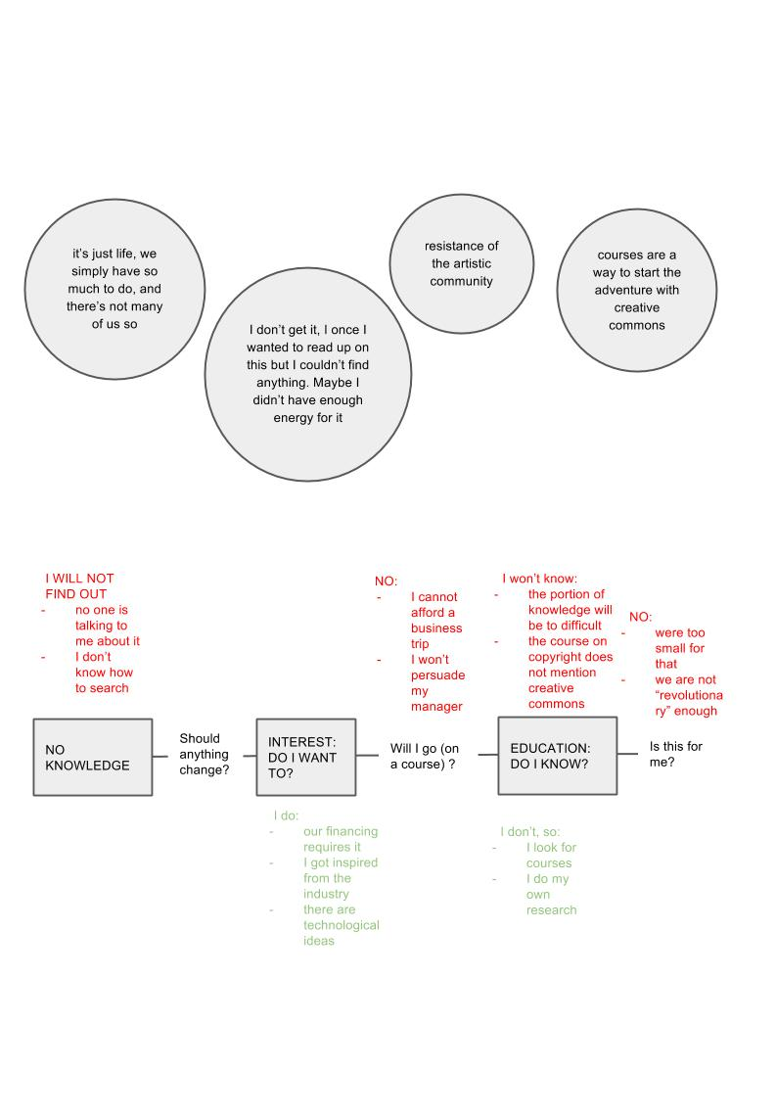
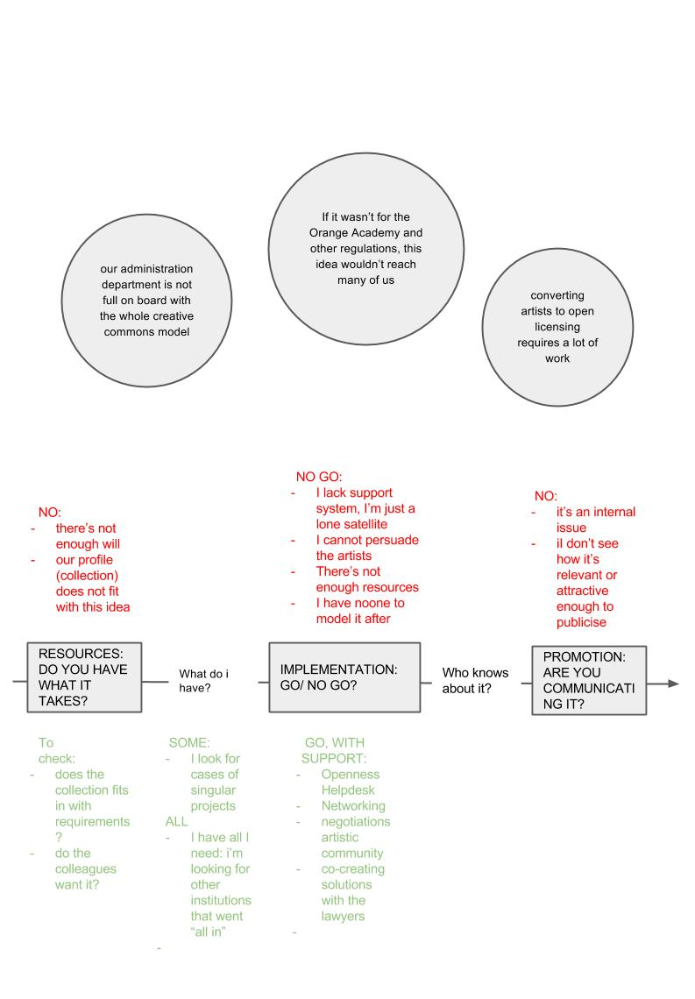
Fig. 1. OpenGLAM Arrow of Progress
Source: Authors

The recipients of the study will often be not researchers but practitioners in the given field. This gives an interdisciplinary touch to the communication of results. The terminology borrowed from other scientific discourses or practical contexts in which the recipient of the report operates, helps to anchor the knowledge shared in the report within the structures that are familiar to the recipient. As obvious as this may sound, the list of things that need taking care of in the course of research is so long, that there is a very high risk of getting overly entangled in the jargon, especially due to the amount of advanced analytical work that precedes reporting.
And so, during our e-competence research we found it very useful to refer to what we knew about the learning process and not only to the sociological aspect of the phenomenon. Also, what we diagnosed to be the key missing “ingredient” of the coaches’ competences was not computer science but andragogy. That is why, in the recommendations made in our report we chose to provide a set of guidelines regarding the coaches’ soft skills. That is how the Digital Coach Kit came to being. It was a guidebook for practical work which, rather than explain apps and keyboard shortcuts, contained tips on working with groups and running courses. The guidelines were as follows:
- Getting to know the group – elements of e-competence intertwined with other areas of knowledge
- Assessing the current state of knowledge – a two-step process comprising both a declarative part and practical exercise
- Demystifying the computer and the Internet – practical tasks to minimize the fear of the unknown
- Metaphors and comparisons – making it easier to understand with terms of what is already learned
- Learning through repetition – reserving time during the course of workshop
- Learning through fun – practical competitive tasks, using gamification
- Teams of coaches – a minimum of two coaches with assigned roles, working with the same group
- Building the sense of purpose – individual tasks seen as part of a bigger project with a clear purpose
- Creativity and sense of agency – creating and co-creating a variety of “works” as part of the training
- “Different speeds” – adjusting the elements of the course to the different learning speeds of its participants, i.e. extra tasks for frontrunners
- Foreign language and digital lingo - getting used to the online slang as part of a language course instead of a inattentive use of the terminology
- Digital interdisciplinarity – cementing the newly-acquired skills into other familiar areas of knowledge

To illustrate the benefits of those guidelines, let us consider the statement made by a female participating in a professional development course for over 45s: “We have always had this specialist counselling and I have always sat in the corner, quiet as a mouse. But this time around we had an hour-long discussion”.
While those guidelines may seem obvious to educators and learning methods’ specialists, we should bear in mind that they may be useful to digital coaches who very often come from a technical, computer science-related background. Somewhat paradoxically, a high level of specialization in information and communication technologies may remove them from other types of discourse and impair their development of soft skills. That is because ICT often carries a “halo of expertise” which creates mutual distance. Taking inspiration from this example, we should always keep in mind the value of the interdisciplinary and relational approach to Internet research and avoid getting seduced by the network of new technologies at every stage of the research.

REFERENCES
Geertz, C. (2005). Interpretacja kultur. Wybrane eseje. [The interpretation of cultures selected
essays], Ktaków: Wydawnictwo Uniwersytetu Jagiellońskiego.
Fatyga, B., Górniak, K., & Zieliński, P. (2000), DWIE EUROPY. Młodzi Niemcy i młodzi Polacy
- wzajemne postrzeganie pod koniec wieku [TWO EUROPE. Young Germans and young
Poles - mutual perception of the end of the century] Warszawa: Fundacja Współpracy
Polsko-Niemieckiej, Instytut Badań nad Podstawami Demokracji.
Filiciak, M., Mazurek, P., & Growiec, K. (2013). Korzystanie z mediów a podziały społeczne.
Kompetencje medialne Polaków w ujęciu relacyjnym [The use of media and social
divisions. Poles’ media competences from a relational perspective]. Warszawa: Centrum
Cyfrowe: Projekt Polska. Retrieved from
http://ngoteka.pl/bitstream/handle/item/215/korzystanie%20z%20mediow%20a%20podzialy%20spoleczne.pdf?sequence=3.
Filiciak, M., Danilewicz, M., Buchner, A., & Zaniewska, K. (2012), Tajni kulturalni. Obiegi
kultury z perspektywy twórców sieciowych węzłów wymiany treści [Undercover agents of
culture. Cultre circuts from the perspective of content exchange hubs creators].
Warszawa, Centrum Cyfrowe: Projekt Polska. Retrieved from http://www.ngoteka.pl/bitstream/handle/item/146/Tajni_Kulturalni_Raport.pdf?sequence=1.
Gurycka, A. (1996) Typologie i funkcje obrazu świata w umyśle człowiek [Typology and
functions of the image of the world in the mind of man]. Poznań: Wydawnictwo Fundacji
Humaniora.
Goffman, E. (2010) Analiza ramowa. Esej z organizacji doświadczenia [Frame Analysis. An
Essay on the Organization of Experience]. Nomos: Kraków.
Robin, R. (1980), „Badanie pól semantycznych: doświadczenia Ośrodka Leksykologii Politycznej
w Saint – Cloud”. In: M. Głowiński (Ed.), Język i społeczeństwo [Language and Society]
(pp. 252-281). Warszawa: Czytelnik.
Malinowski, B. (1981) Argonauci Zachodniego Pacyfiku, Dzieła, t. III [Argonauts of the
Western Pacific, Collected Works, Vol. III]. Warszawa: PWN.
Konecki, K. (2000) Studia z metodologii badań jakościowych. Teoria ugruntowana [Studies of
the methodology of qualitative research. Grounded Theory]. Warszawa: PWN.
Kłosiński, M. (1994) Obraz bezrobocia i bezrobotnych w polskiej prasie [Image of
unemployment and the unemployed in the Polish press]. Kultura i społeczeństwo, 3,
151-156.

The method of semantic field analysis was first used and written about by a team of researchers led by Regine Robin of the Saint Cloud Centre for Political Lexicology. In their work, Robin’s team always followed the basic postulates according to which “writing is never transparent. Searching for the meaning of a piece of writing, a sentence, a word requires a degree of textwork. One needs to break down an utterance and disturb its order and then piece it back together, while preserving the same clarity of meaning (Głowiński, 1980).In the method developed by the Saint-Cloud researchers, semantic fields are developed for each given key word. This serves to create the “conceptual network” of the key word, i.e. to discover its various contexts and interactions with and within other words or phrases. The research procedure involves finding in a given text, all the words and phrases that serve a specific role in the context of the key word (epithets, equivalents, antonyms etc.).
The definitions were created using the method invented by Marek Kłosiński - a reconstruction of covert equivalent definitions. They were consistent with Regine Robin’s idea of “piecing the text back together” which leads to the discovery of its actual meaning.

